**Multi-Agency Safeguarding Arrangements (MASA)**

Children and Young People

2022-2024

Contents

1. What are Multi-Agency Safeguarding Arrangements (MASA) for children and young people? 3

2. Who are the safeguarding partners? 3

3. Responsibilities of the Safeguarding Partners 4

4. Leadership, Governance & Accountability 5

5. Relevant Agencies 6

6. Geographical Area 8

7. The Strategic Role of Safeguarding Partners 9

8. The Operational Role of Safeguarding Partners 9

9. Voice of the child 10

10. Independent Scrutiny 11

11. Training 12

12. Funding and business support 13

13. Child Death Review Arrangments 13

14. Links with other Partnerships 14

15. Information Sharing 14

16. Dispute resolution 14

17. Structure (see: Appendix 1 – Terms of Reference) 15

18. Business Plan 16

19. Review of the arrangements 16

Appendix 1 – Terms of Reference 17

Introduction

The document sets out how we will work together and with other agencies to safeguard and promote the welfare of all children in Gateshead. The term ‘children’ used throughout the document refers to both children and young people. We are committed to the aspirations and content set out in these arrangements and will engage widely to ensure its success. We are also committed to the need to respond flexibly and creatively to new challenges as they arise.

Our safeguarding arrangements are designed to offer us the chance to work more effectively and with joint purpose to protect children and young people and support those who most need our help into adulthood. We agree and state our intention to ensure these plans help us continue to promote and improve the safety, welfare and health of children and families in Gateshead.

# What are Multi-Agency Safeguarding Arrangements (MASA) for children and young people?

There is a shared and collective responsibility between organisations and agencies to safeguard and promote the welfare of children in Gateshead.[1]

Responsibility for this joined up approach locally rests with three ***Safeguarding Partners*** who have a shared and equal duty to have in place robust arrangements to work together to safeguard and promote the welfare of children in Gateshead.

The Gateshead Multi-agency Safeguarding Arrangements for Children and Young People sets out how the Safeguarding Partners will work together, and with other agencies, to safeguard and promote the welfare of all children in Gateshead.

# Who are the safeguarding partners?

A safeguarding partner in relation to a local authority area in England is defined under the Children Act 2004 (as amended by the Children and Social Work Act 2017) as:



# Responsibilities of the Safeguarding Partners

# Leadership, Governance & Accountability

Strong leadership is critical for the Gateshead multi-agency safeguarding arrangements to be effective in bringing together various organisations and agencies. All three safeguarding partners have equal and joint responsibility for local safeguarding.

**The three Safeguarding Partners with delegated responsibility in Gateshead are:**

• Strategic Director (DCS) of Children’s Services – Gateshead Council

• Director of Nursing – North East & North Cumbria Integrated Care Board[2]

• Designated Chief Superintendent – Northumbria Police

The Safeguarding Partners will discharge their broader responsibilities through the Gateshead Safeguarding Children Partnership (GSCP) and its groups; these are made up of those relevant agencies set out in statutory regulation (see *section 5*). Groups and task and finish groups will report to the GSCP on a regular basis.

In situations that require a clear, single point of leadership all three Safeguarding Partners will decide who leads on specific arrangements or issues.

A Gateshead Partnership Group that consists of the Independent Scrutineer of the GSCP and Chairs of Safeguarding Adults Board, Community Safety Board, Health and Wellbeing Board, Domestic Abuse Partnership Board and the Youth Justice Board will meet to consider cross cutting safeguarding and community safety issues for Gateshead as a whole. This is one of the ways in which the Safeguarding Partners will work more closely with partnerships to strengthen our approach to working across the life course and reducing the likelihood of harm to children, young people and adults. The group will meet every six months and will report into its’ constituent partnerships as appropriate.

The Safeguarding Partners may delegate decision making to the GSCP and its groups to ensure their responsibilities are fulfilled in a timely way.

Gateshead Council provides legal, communications and media advice to the Safeguarding Partners and the GSCP, however, individual organisations reserve the right to seek advice provided by their organisation. Gateshead Council also acts as the Data Controller for Freedom of Information requests.

# Relevant Agencies

Relevant agencies[3] are those organisations and agencies whose involvement the Safeguarding Partners consider is required to safeguard and promote the welfare of children in Gateshead and must act in accordance with the arrangements. Strong effective multi-agency arrangements are ones that are responsive to local circumstances and engage the right people.

Where a Relevant Agency has a national remit, such as the British Transport Police and Cafcass, memorandums of understanding will set out how they will contribute to the local arrangements.

# Geographical Area

The boundaries for the Gateshead Safeguarding Children Partnership will be those of Gateshead Council. However, work will continue across the Northumbria region[4] via the Business Managers network and the Tyne, Wear & Northumberland Safeguarding Partnership.

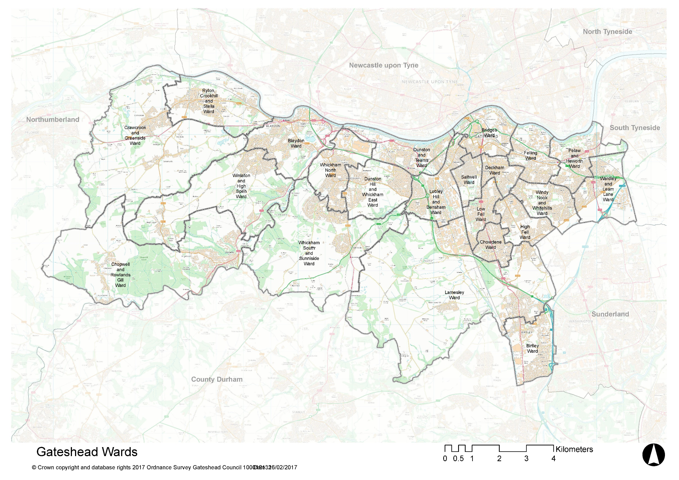

# The Strategic Role of Safeguarding Partners

The safeguarding partners (as a strategic decision-making arrangement accountable for effective multi-agency practice) must have clear functions (set out below). This puts beyond doubt that the lead representative in arrangements should be at a sufficiently senior level to fulfil these functions and there should be transparency about who it is delegated to.

## Strategic functions for strategic arrangements:

# The Operational Role of Safeguarding Partners

To enable senior safeguarding partners to focus on strategic issues, there needs to be clarity about the functions of operational multi-agency working and clear expectations for the operational aspect of partnership working locally, which would report into the strategic arrangements.

A set of joint and equal responsibilities is set out below. This list is not necessarily exhaustive and provides a foundation for further development. In fulfilling these functions partners should involve a wider set of relevant agencies, such as probation, community groups and housing.

## Strategic responsibilities for operational arrangements:

|  |
| --- |
| **Monitor, understand and improve the overall contributions of partners to safeguarding and promoting the welfare of children:** |
| * ensure all multidisciplinary and multi-agency working for Family Help and child protection is effective, including ensuring professionals have the time and resources needed * ensure information is shared and used effectively, and ensuring that information sharing agreements are in place and there is adequate staff training * undertake rapid reviews of serious child safeguarding cases. Establish arrangements to commission and oversee Local Child Safeguarding Practice Reviews and decide when these should be carried out. Implement learning from these alongside national reviews from the Child Safeguarding Practice Review Panel * implement the proposed reforms in national review |

|  |
| --- |
| **Develop a strong understanding of the needs and experiences of relevant children and families in the area and ensure services respond to this need:** |
| * use data and intelligence to improve our understanding of the needs and experiences of children and young people and ensure that this informs service development and improvement * develop a shared understanding of eligibility for Family Help alongside the National Children’s Social Care Framework and what constitutes significant harm, and ensure these are applied consistently * respond to feedback from children and families about their experiences of services |

|  |
| --- |
| **Align responses where there are tensions in organisational objectives that are a barrier to acting in the best interests of children and families:** |
| * ensure that agencies’ responses to children at risk of extra familial harms are aligned (for example when a child is both a victim and a perpetrator of crime) * align responses to families where the needs of either the child or a family not being met by other partners, will impact systemically on help or protection of a child |

# Voice of the child

The voice of the child is at the heart of our multi-agency safeguarding arrangements. Involving children and families is essential to safeguarding in Gateshead both in contributing to delivering the GSCPs vision and in helping to scrutinise and review the partnership arrangements themselves.

The GSCP aims to make use of the existing systems, groups and forums to gather the views of children and families to encourage children to have their say, share their views and experiences, challenge and support local decision makers and shape and influence strategic planning, commissioning and service provision.

# Independent Scrutiny

The [Act](https://www.socialworkengland.org.uk/about/publications/children-and-social-work-act-2017/) requires multi-agency arrangements are to be independently scrutinized, and the [guidance](http://www.workingtogetheronline.co.uk/chapters/chapter_three.html#indep_scrut)[5] explains how scrutiny could take place.

**The GSCP have appointed an Independent Scrutineer who will:**

The chairing of the Partnership meetings will form part of the Independent Scrutiny role and will fulfil the objective to act as a constructive critical friend, promote challenge and reflection to drive continuous improvement (as set out in WT2018). It should also help in seeking assurance and assessing whether the three safeguarding partners are fulfilling their statutory obligations.

**In addition to the Independent Scrutineer, other scrutiny arrangements in Gateshead are as follows:**

* **Lay members x2** who attend both GSCP and SAB meetings;
* **The Section 11 audit** forms part of the independent scrutiny arrangements and feeds into the reporting requirements as set out in [Chapter 3 of Working Together to Safeguard Children 2018](http://www.workingtogetheronline.co.uk/chapters/chapter_three.html) – this is carried out sub-regionally every two years – the same audit tool is used across six areas. Audit tool sent out at the same time and responses collated (Gateshead lead on this) – this could be themed audits, to help inform agreed regional priority areas of work.
* **Use of local authority and ICB scrutiny and health and wellbeing committees.**
* **Peer challenge** – including regional collaboration via Tyne, Wear & Northumberland Safeguarding Partnership (TWNSP), Association Directors of Children’s Services (ACDS) and Business Managers Network.
* **Engagement of children and young people** – via partnership agencies (including LA, ICB, Police).
* **Independent inspectorate’s single assessment of the individual safeguarding partners and the Joint Targeted Area Inspections** – [*Ofsted*](https://www.gov.uk/government/organisations/ofsted), [*Care Quality Commission*](https://www.cqc.org.uk/) (CQC), [*Her Majesty’s Inspectorate of Constabulary and Fire & Rescue Services*](https://www.justiceinspectorates.gov.uk/hmicfrs/) (HMICFRS).

# Training

Safeguarding partners commission multi-agency training and learning activities based on needs analysis and agreed via the GSCP’s Learning and Improvement Group. This needs analysis is informed by the GSCPs priorities and takes into account practice issues arising from for example local safeguarding practice reviews, multi-agency case audits, inspections, local and national priorities, section 11 audits, feedback from training activities and emerging issues.

The method of delivery of multi-agency training is based on what is most appropriate and effective and includes e-learning, face to face training, virtual training, conferences, case studies and action learning activities. The GSCP will continue to be creative and innovative in developing learning interventions.

This is evaluated in a variety of ways and includes feedback from practitioners, practice audits, supervision and examples of practice changes. Impact of learning is monitored and the findings reported back to the GSCP Executive annually.

The Gateshead Safeguarding Children Partnership, Gateshead Safeguarding Adults Board and Gateshead Community Safety Board have produced a comprehensive joint training programme for partner agencies operating in Gateshead. The training programme is co-ordinated by Gateshead Council Workforce Development. See: [Training Programme](https://www.gateshead.gov.uk/article/6670/Safeguarding-and-Community-Safety-training)

# Funding and business support

The work of the GSCP is supported by a business manager hosted by Gateshead Council. The safeguarding partners are committed to equitable and proportionate funding of this business support and the work of the GSCP as a whole.

Contributions to support the local arrangements have been agreed for 2022/23. The three partners will discuss, identify, agree and maintain the budget for the GSCP for each financial year (April-March). This funding will also include the cost of child safeguarding practice reviews, which will be agreed as and when required.

# Child Death Review Arrangments

The purpose of a child death review is to help prevent further such child deaths and improve the experience of bereaved families, and professionals involved in caring for children. The responsibility for ensuring child death reviews are carried out is held by the **child death review partners**, who are the local authority and the Integrated Care System/Board.

[Statutory and Operational Guidance](https://www.gov.uk/government/publications/child-death-review-statutory-and-operational-guidance-england) sets out the full process that follows the death of a child who is normally resident in England. It builds on the statutory requirements set out in [Chapter 5 of Working Together to Safeguard Children 2018](https://www.workingtogetheronline.co.uk/chapters/chapter_five.html) and clarifies how individual professionals and organisations across all sectors involved in the child death review should contribute to reviews.

In order to comply with the statutory guidance – that Child Death Overview Panels should cover a geographical footprint that enables it to typically review at least 60 child deaths per year – the CDR partners for the following localities have agreed to establish one CDOP to cover their combined geographical footprint:

This CDOP, known as the **North and South of Tyne CDOP,** will typically review at least 60 deaths per year which will better enable thematic learning in order to identify potential safeguarding or local health issues that could be modified in order to protect children from harm and, ultimately, save lives.

The CDOP will carry out its functions mindful of the potential impact upon the bereaved family and in accordance with the [CDR Statutory Guidance](https://www.gov.uk/government/publications/child-death-review-statutory-and-operational-guidance-england). The CDOP is the final assurance point once all multi-agency information has been collected, collated and analysed at a local level via the Child Death Review Meeting and professionals who have known the child and family, including the key worker. CDOP use eCDOP to support them in the collation of information and learning.

**CDOP will report into Public Health and the Health and Wellbeing Board and report to GSCP on an annual basis.**

# Links with other Partnerships

The Safeguarding Partners work together and with local partners and partnerships, including the Health and Wellbeing Board, Safeguarding Adult Board, Domestic Abuse Partnership Board, Community Safety Board, Youth Justice Board and those across the North and South of Tyne and the region, to ensure an effective joined-up response to reduce the risk of harm to children and to improve outcomes.

# Information Sharing

The GSCP members shall keep confidential any information obtained because of inter-agency co-operation unless disclosure of the information is necessary to discharge the functions of the Safeguarding Partners as set out in Working Together to Safeguard Children (2018) and the local safeguarding arrangements.

Safeguarding partners may require any person, organisation or agency to provide them, any relevant agency, reviewer or another person or organisation or agency, with specified information. This must be information which enables and assists the Safeguarding Partners to perform their functions to safeguard and promote the welfare of children in Gateshead, including local and national child safeguarding practice reviews.

The person or organisation to whom a request is made must comply with such a request and if they do not do so, the Safeguarding Partners may take legal action against them. As public authorities, Safeguarding Partners must be aware of their own responsibilities under the relevant information law and have regard to guidance provided by the Information Commissioner’s Office when issuing and responding to requests for information.

The GSCP’s [Information Sharing Protocol](https://proceduresonline.com/trixcms1/media/12198/ispv50222-approved.pdf) has been developed to address information sharing both at strategic level and operational level within the arenas of Safeguarding Children and Adult Safeguarding. It is intended that agencies with the potential to be involved in safeguarding investigations will sign up to the use of this protocol. This protocol is agreed with the purpose of ensuring compliance with the Data Protection Act 2018 and the UK General Data Protection Regulations (UK GDPR) and the Human Rights Act 1998. This protocol is underpinned by *service specific operational agreements* that are designed to meet the specific data sharing needs of that service.

# Dispute resolution

Transparency, openness, and a willingness to understand and respect individual and agency views are a core aspect of multi-agency working. However, there may be occasions where individuals / agencies working with children and families disagree on how best to keep children safe and promote their welfare.

All partner agencies have a responsibility to resolve any professional disagreement between them promptly and amicably in accordance with the [Escalation Policy](https://www.proceduresonline.com/nesubregion/p_escalation.html). In the unlikely event that a disagreement cannot be resolved at local level by senior managers within the respective agencies, it can be escalated to the three Statutory Safeguarding Partners.

Whistleblowing Procedures provide an additional important route for staff to raise concerns in a safe process that protects their position. The Safeguarding Partners and the wider partnership will adhere to their own whistleblowing procedures.

# Structure

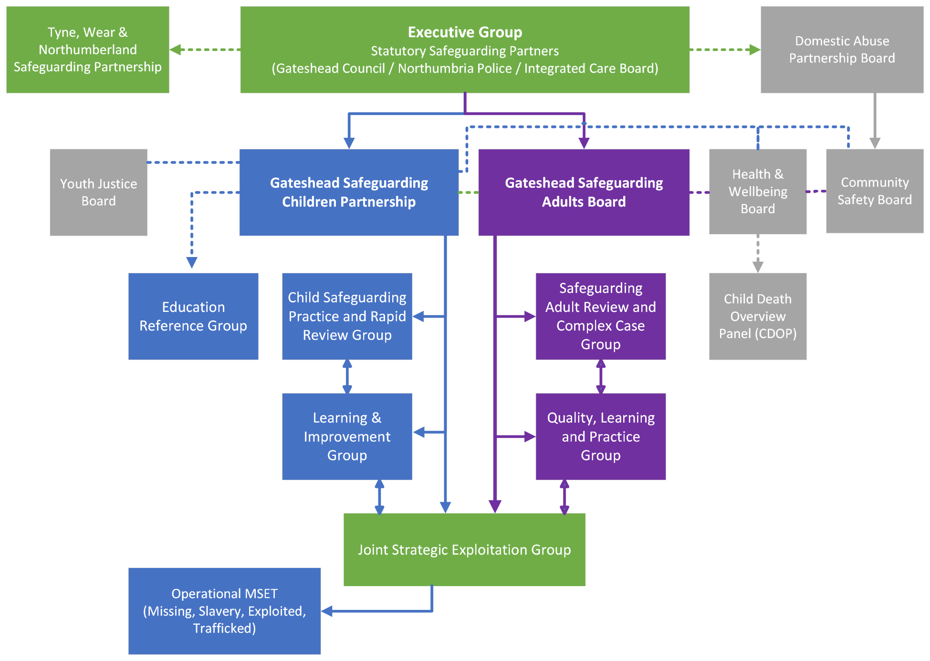

# Business Plan

The Gateshead Safeguarding Children Partnership’s Business Plan sets the strategic direction for the GSCP. The plan identifies specific priorities for action and is clear about roles and accountability. The Business Plan emphasises the role of GSCP in **leading** the safeguarding agenda, and in committing to an approach which **learns** lessons, embeds good practice and which is continually influenced by the views of children and young people. This Business Plan is overseen and monitored by GSCP via the Learning & Improvement group. Progress on agreed priorities will be included in the GSCPs annual report.

# Review of the arrangements

Multi-Agency Safeguarding Arrangements for Children and Young People will be reviewed in xxx. Any proposed amendment to the arrangements will be in consultation with the wider partners.

1. Safeguarding and promoting the welfare of children is defined as: protecting children from maltreatment; preventing impairment of health or development; ensuring that children grow up in circumstances consistent with the provision of safe care; and tacking action to enable all children to have the best outcomes
2. ***The ICB will continue to represent NEAS and NHS England***
3. HM Government (2018) [The Child Safeguarding Practice Review and Relevant Agency (England) Regulations 2018](https://www.legislation.gov.uk/ukdsi/2018/9780111167540/contents)
4. The region covers the 6 local authority areas of North and South of Tyne: Northumberland, North Tyneside, Newcastle, Gateshead, South Tyneside, and Sunderland; the 5 Clinical Commissioning Groups for those areas; and Northumbria Police.
5. [Working Together 2018: Chapter 3 Paragraphs 31 to 35](http://www.workingtogetheronline.co.uk/chapters/chapter_three.html#indep_scrut)